WAVES ON A STRING SIMULATION Name(s)__________________
Guiding Question:
How do the properties of amplitude and frequency affect wavelength?
Start:
- Go to mzpass.weebly.com. Click on CURRICULUM, select ENERGY, then WAVES. Run from the website or click on the PHET link and download for full screen.
- For this activity you will be collecting data to explore three properties of a wave.
- Explore the simulation with your partner. Be sure to click on all the buttons.
- For the first set of investigations, we will look at amplitude.
  - you need to be on
  - The rest of your screen should be set up like this:
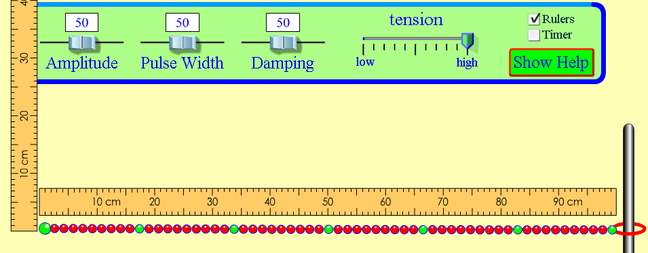
Look over the data table, on the back, and discuss how get the data you need.
moves the wave.

Amplitude setting | Height of wave at the start  (be sure your ruler is lined up correctly)  LOOSE FIXED NO END | Distance ring moves on pole (end)  LOOSE FIXED NO END
100
50
5
Discuss what happened to the energy at the end of the wave when we changed the amplitude?________________________________________________________
Repeat number 4 – using and then
- For this next part we will investigate wavelength.
  - You need to be on
  - The rest of your screen should be set up like we did for number 4.
  - Try out the button after you hit pause. This may be useful for collecting data.
Data:
wavelength = _______ cm

Wavelength = _____ cm

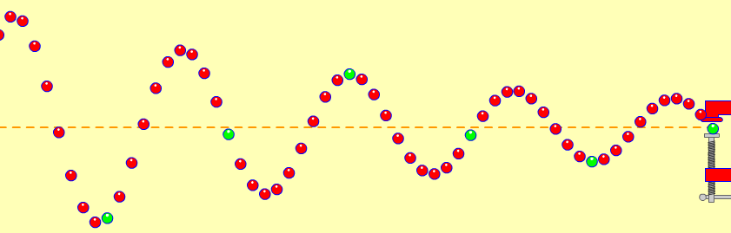
7. Talk about the wavelength of the two waves you measured.
- Discuss & write below how they were similar and how they were different.
- _________________________________________________
Teacher check point
Part 2: For the third set of investigations, we will look at frequency.
  - you need to be on
  - open both the ruler and timer
  - controlled variables: Amplitude and damping should be left on 50 and tension stays on “high”
  - Remember, to stop or slow the wave use pause/play and .
- Look over the data table and discuss how you will collect the data you need.
- Before you begin… try a little practice using the timer:
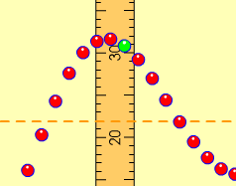
Turn the timer on, off and reset the timer while waves are moving.
- Practice counting waves passing a given point:
Move the vertical ruler so that it is along the wave’s path. This will be the point where you watch waves pass and count them. Count 5 waves passing the ruler. Change the frequency and count again.
***NOTE it is easier to do this in the “STEP” mode.

Fill in the table by working together, one person counting the waves and the other using the timer.
Data:
frequency | Time interval | Number of waves: |  |  | Average number of waves counted in 10 second period | Number of waves in 1 second  _{frequency**}
 |  | Trial #1 | Trial #2 | Trial #3
10 | 10 seconds
50 | 10 seconds
100 | 10 seconds
*To find frequency, divide the average number of waves counted by the time interval.

5. Talk about the data.
- Decide on a way your group can explain wave frequency to the class.
- Write your idea(s) on the lines.
___________________________________________________________________
___________________________________________________________________
CONCLUSION Our data show that the higher the number chosen for the frequency on the slider, the _________________ the number of waves passing ____________________ in a certain amount of ________________________.
6. Use arrows, or draw on the end of the wave, to show what will happen when the amplitude is increased:
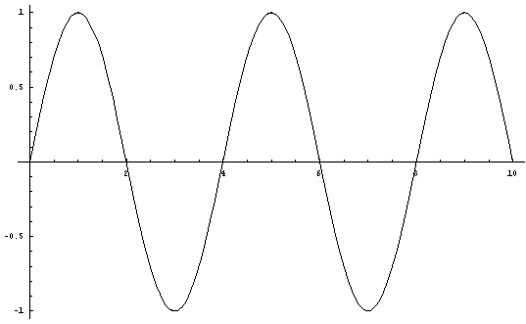
Line of --origin------
7. Draw on the end of wave, to show what will happen when the frequency is increased:

Line of --origin------

